JAVAMS05 Messaging with Cloud Pub/Sub

**Overview**

In this series of labs, you take a demo microservices Java application built with the Spring framework and modify it to use an external database server. You adopt some of the best practices for tracing, configuration management, and integration with other services using integration patterns.

In this lab, you enhance your application to implement a message handling service with Cloud Pub/Sub so that it can publish a message to a topic that can then be subscribed and processed by other services.

Cloud Pub/Sub is a fully managed, real-time messaging service that enables you to send and receive messages between independent applications. Cloud Pub/Sub brings the scalability, flexibility, and reliability of enterprise message-oriented middleware to the cloud. By providing many-to-many, asynchronous messaging that decouples senders and receivers, Cloud Pub/Sub enables secure and highly available communication between independently written applications. Cloud Pub/Sub delivers low-latency, durable messaging that helps developers quickly integrate systems hosted on the Google Cloud Platform and externally.

**Objectives**

In this lab, you learn how to perform the following tasks:

* Enable Cloud Pub/Sub and create a Cloud Pub/Sub topic
* Use Spring to add Cloud Pub/Sub support to your application
* Modify an application to publish Cloud Pub/Sub messages
* Create a Cloud Pub/Sub subscription
* Modify an application to process messages from a Cloud Pub/Sub subscription

**Task 0. Lab Preparation**

**Access Qwiklabs**

**How to start your lab and sign in to the Console**

1. Click the **Start Lab** button. If you need to pay for the lab, a pop-up opens for you to select your payment method. On the left is a panel populated with the temporary credentials that you must use for this lab.

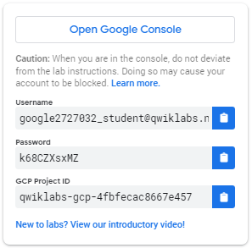

1. Copy the username, and then click **Open Google Console**. The lab spins up resources, and then opens another tab that shows the **Choose an account** page.

***Tip:*** Open the tabs in separate windows, side-by-side.

1. On the Choose an account page, click **Use Another Account**.

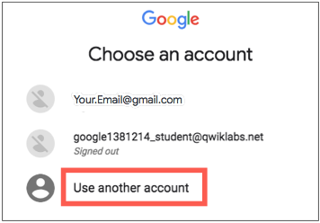

1. The Sign in page opens. Paste the username that you copied from the Connection Details panel. Then copy and paste the password.

***Important:*** You must use the credentials from the Connection Details panel. Do not use your Qwiklabs credentials. If you have your own GCP account, do not use it for this lab (avoids incurring charges).

1. Click through the subsequent pages:
   * Accept the terms and conditions.
   * Do not add recovery options or two-factor authentication (because this is a temporary account).
   * Do not sign up for free trials.

After a few moments, the GCP console opens in this tab.

**Note:** You can view the menu with a list of GCP Products and Services by clicking the **Navigation menu** at the top-left, next to “Google Cloud Platform”. 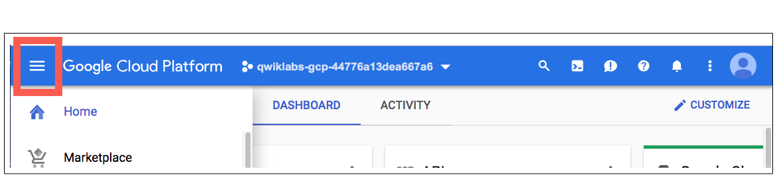

After you complete the initial sign-in steps, the project dashboard appears.

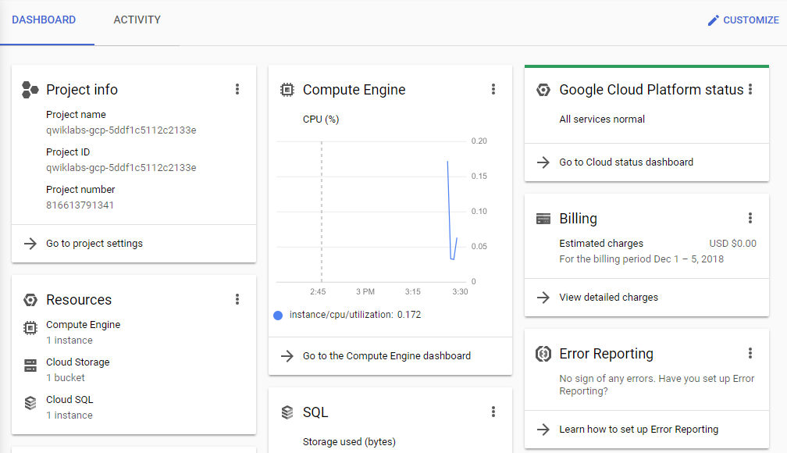

**Fetch the application source files**

To begin the lab, click the **Activate Cloud Shell** button at the top of the Google Cloud Console. To activate the code editor, click the Open Editor button on the toolbar of the Cloud Shell window. This sets up the editor in a new tab with continued access to Cloud Shell.

**Note:** a Cloud Storage bucket that is named using the project ID for this lab is automatically created for you by the lab setup. The source code for your applications is copied into this bucket when the Cloud SQL server is ready. You might have to wait a few minutes for this action to complete.

1. In the Cloud Shell command line, enter the following command to create an environment variable that contains the project ID for this lab:

export PROJECT_ID=$(gcloud config list --format 'value(core.project)')

1. Verify that the demo application files were created.

gsutil ls gs://$PROJECT_ID

1. Copy the application folders to Cloud Shell.

gsutil -m cp -r gs://$PROJECT_ID/* ~/

1. Make the Maven wrapper scripts executable. Now you're ready to go!

chmod +x ~/guestbook-frontend/mvnw

chmod +x ~/guestbook-service/mvnw

**Task 1. Enable Cloud Pub/Sub API**

1. In the Cloud Shell, enable Cloud Pub/Sub API.

gcloud services enable pubsub.googleapis.com

**Task 2. Create a Cloud Pub/Sub topic**

In this task, you create a Cloud Pub/Sub topic to send the message to.

1. Use gcloud to create a Cloud Pub/Sub topic.

gcloud pubsub topics create messages

**Task 3. Add Spring Cloud GCP Pub/Sub starter**

In this task, you update the guestbook frontend application's pom.xml file to include the Spring Cloud GCP starter for Cloud Pub/Sub in the dependency section.

1. In the Cloud Shell code editor, open ~/guestbook-frontend/pom.xml.
2. Insert the following new dependency at the end of the <dependencies> section, just before the closing </dependencies> tag:

<dependency>

<groupId>org.springframework.cloud</groupId>

<artifactId>spring-cloud-gcp-starter-pubsub</artifactId>

</dependency>

**Task 4. Publish a message**

In this task, you use the PubSubTemplate bean in Spring Cloud GCP to publish a message to Cloud Pub/Sub. This bean is automatically configured and made available by the starter. You add PubSubTemplate to FrontendController.

1. Open guestbook-frontend/src/main/java/com/example/frontend/FrontendController.java in the Cloud Shell code editor.
2. Add the following statement immediately after the existing import directives:

import org.springframework.cloud.gcp.pubsub.core.*;

1. Insert the following statement between the lines private GuestbookMessagesClient client; and @Value("${greeting:Hello}"):

@Autowired

private PubSubTemplate pubSubTemplate;

1. Add the following statement inside the if statement to process messages that aren't null or empty, just below the comment // Post the message to the backend service:

pubSubTemplate.publish("messages", name + ": " + message);

The code for FrontendController.java should now look like the screenshot:

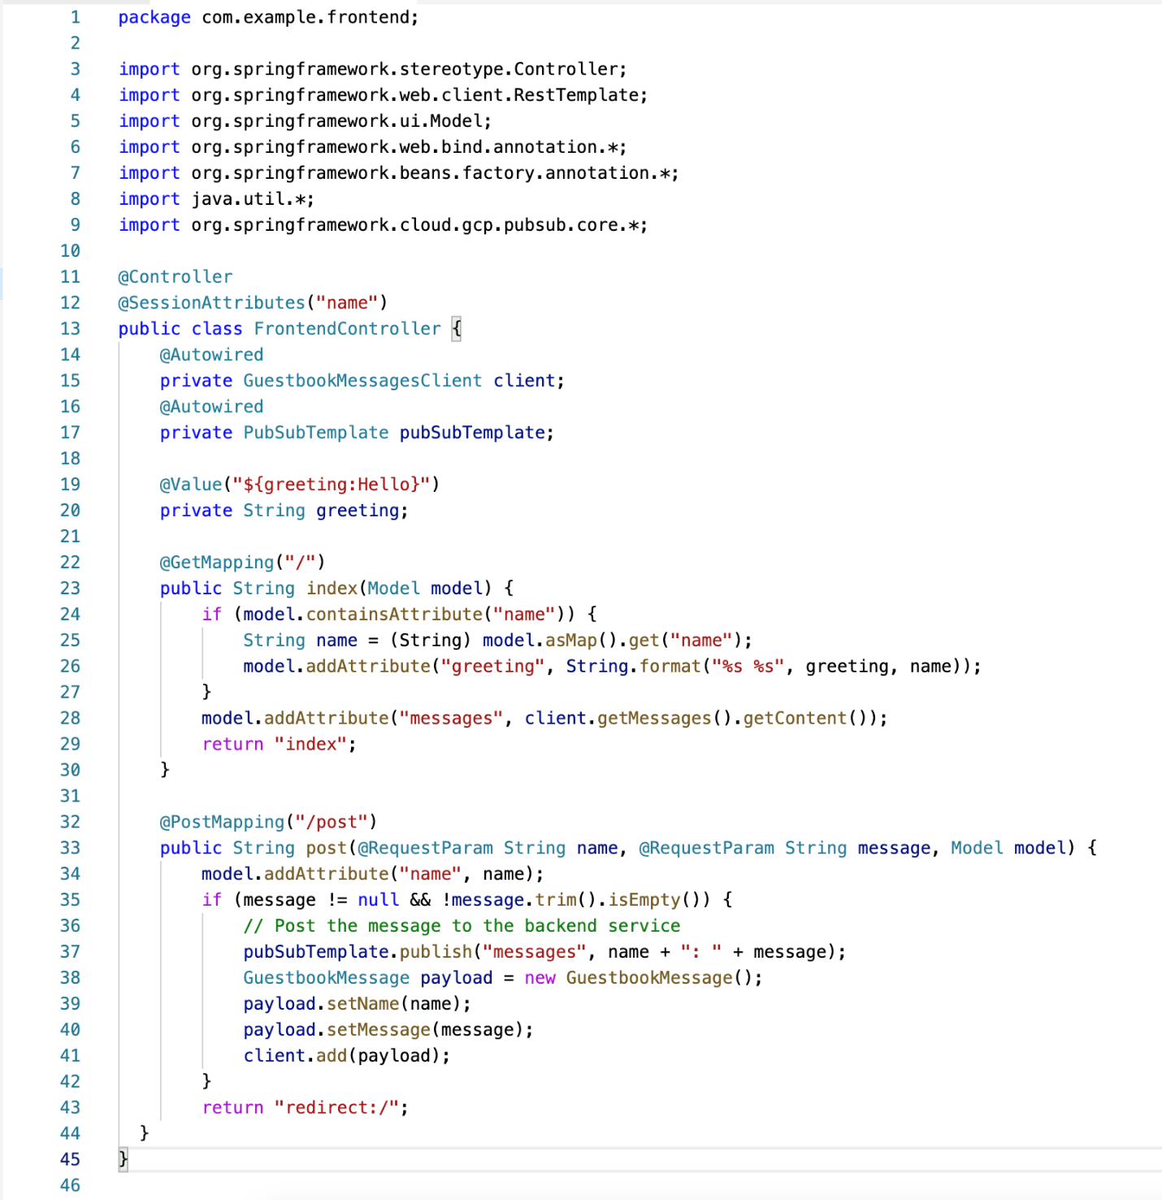

**Task 5. Test the application in the Cloud Shell**

In this task, you run the application in the Cloud Shell to test the new Cloud Pub/Sub message handling code.

1. In the Cloud Shell change to the guestbook-service directory.

cd ~/guestbook-service

1. Run the backend service application.

./mvnw spring-boot:run -Dspring-boot.run.jvmArguments="-Dspring.profiles.active=cloud"

The backend service application launches on port 8081.This takes a minute or two to complete and you should wait until you see that the GuestbookApplication is running.

Started GuestbookApplication in 20.399 seconds (JVM running...)

1. Open a new Cloud Shell session tab to run the frontend application by clicking the plus (+) icon to the right of the title tab for the initial Cloud Shell session.
2. Change to the guestbook-frontend directory.

cd ~/guestbook-frontend

1. Start the frontend application with the cloud profile.

./mvnw spring-boot:run -Dspring.profiles.active=cloud

1. Open the Cloud Shell web preview and post a message.

The frontend application tries to publish a message to the Cloud Pub/Sub topic. You will check if this was successful in the next task.

**Task 6. Create a subscription**

Before subscribing to a topic, you must create a subscription. Cloud Pub/Sub supports pull subscription and push subscription. With a pull subscription, the client can pull messages from the topic. With a push subscription, Cloud Pub/Sub can publish messages to a target webhook endpoint.

A topic can have multiple subscriptions. A subscription can have many subscribers. If you want to distribute different messages to different subscribers, then each subscriber needs to subscribe to its own subscription. If you want to publish the same messages to all the subscribers, then all the subscribers must subscribe to the same subscription.

Cloud Pub/Sub delivery is "at least once." Thus, you must deal with idempotence and you must deduplicate messages if you cannot process the same message more than once.

In this task, you create a Cloud Pub/Sub subscription and then test it by pulling messages from the subscription before and after using the frontend application to post a message.

1. Open a new Cloud Shell tab.
2. Create a Cloud Pub/Sub subscription.

gcloud pubsub subscriptions create messages-subscription-1 \

--topic=messages

1. Pull messages from the subscription.

gcloud pubsub subscriptions pull messages-subscription-1

The pull messages command should report 0 items.

The message you posted earlier does not appear, because the message was published before the subscription was created.

1. Return to the frontend application, post another message, and then pull the message again.

gcloud pubsub subscriptions pull messages-subscription-1

The message appears. The message remains in the subscription until it is acknowledged.

1. Pull the message again and remove it from the subscription by using the auto-acknowledgement switch at the command line.

gcloud pubsub subscriptions pull messages-subscription-1 --auto-ack

**Task 7. Process messages in subscriptions**

In this task, you use the Spring PubSubTemplate to listen to subscriptions.

1. In the Cloud Shell generate a new project from Spring Initializr.

cd ~

curl https://start.spring.io/starter.tgz \

-d dependencies=web,cloud-gcp-pubsub \

-d baseDir=message-processor | tar -xzvf -

This command generates a new Spring Boot project with the Cloud Pub/Sub starter preconfigured. The command also automatically downloads and unpacks the project into the message-processor directory structure.

1. Open ~/message-processor/pom.xml to verify that the starter dependency was automatically added.

...

<dependencies>

<dependency>

<groupId>org.springframework.cloud</groupId>

<artifactId>spring-cloud-gcp-starter-pubsub</artifactId>

</dependency>

<dependency>

<groupId>org.springframework.boot</groupId>

<artifactId>spring-boot-starter-test</artifactId>

<scope>test</scope>

</dependency>

</dependencies>

...

1. To write the code to listen for new messages delivered to the topic, open ~/message-processor/src/main/java/com/example/demo/DemoApplication.java in the Cloud Shell code editor.
2. Add the following import directives below the existing import directives:

import org.springframework.context.annotation.Bean;

import org.springframework.boot.ApplicationRunner;

import org.springframework.cloud.gcp.pubsub.core.*;

1. Add the following code block to the class definition for DemoApplication, just above the existing definition for the main method:

@Bean

public ApplicationRunner cli(PubSubTemplate pubSubTemplate) {

return (args) -> {

pubSubTemplate.subscribe("messages-subscription-1",

(msg) -> {

System.out.println(msg.getPubsubMessage()

.getData().toStringUtf8());

msg.ack();

});

};

}

We added the Web starter simply because it's much easier to put Spring Boot application into daemon mode, so that it doesn't exit immediately. There are other ways to create a Daemon, e.g., using a CountDownLatch, or create a new Thread and set the daemon property to true. But since we are using the Web starter, make sure that the server port is running on a different port to avoid port conflicts.

1. Add this line to change the port on message-processor/src/main/resources/application.properties:

server.port=${PORT:9090}

1. Return to the Cloud Shell tab for the message processor to listen to the topic.

cd ~/message-processor

./mvnw -q spring-boot:run

1. Open the browser with the frontend application, and post a few messages.
2. Verify that the Cloud Pub/Sub messages are received in the message processor.

The new messages should be displayed in the Cloud Shell tab where the message processor is running, as in the following example:

... [main] com.example.demo.DemoApplication : Started DemoApplication...

Ray: Hey

Ray: Hello!

**End your lab**

When you have completed your lab, click **End Lab**. Qwiklabs removes the resources you've used and cleans the account for you.

You'll be given an opportunity to rate the lab experience. Select the applicable number of stars, type a comment, and then click **Submit**.

The number of stars indicates your rating:

* 1 star = Very dissatisfied
* 2 stars = Dissatisfied
* 3 stars = Neutral
* 4 stars = Satisfied
* 5 stars = Very satisfied

You can close the dialog box if you don't want to provide feedback.

For feedback, suggestions, or corrections, use the **Support** tab.

Copyright 2019 Google LLC All rights reserved. Google and the Google logo are trademarks of Google LLC. All other company and product names may be trademarks of the respective companies with which they are associated.